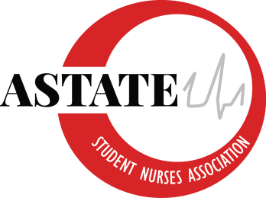

Arkansas State University Student Nurses’ Association
Board of Directors Strategic Planning Meeting
April 28th, 2020
10 am
Zoom
Meeting Minutes

- Call to Order:

- Roll Call:
President: Alannah Davis
Vice President: Charlee Beth Patterson
Secretary: Meredith Pipkin
Treasurer: Anna Powell
NEC Chair: Peyton Hitchings
BTN Chair: Katie Howard
Webmaster: Josie Butkovich
Public Relations: Mikayla Bowers
Senior Class Representative: Nicholas Harris
Junior Class Representative: Tori Woods
Sophomore Class Representative: Dylan Western
Accelerated Class Representative: Brenda Awuah
Faculty Advisor: Addie Fleming
Faculty Advisor: Kayla Travis
Visitors:
Announcements
- Approval of meeting minutes from 4-1-2020.
- Financial Report-
- Congratulations to our 2020-2021 SNA Board of Directors!
- Congratulations to Anna Leigh for winning the Financial award for Nationals! You’re awesome!
- All of the current nursing students and previous nursing student received their emergency relief money and were very appreciative. I’m so glad we were able to help others during this time.

- New Business/ Follow Up
- Pinning Ceremony (Nicholas Harris)
- More CPR Instructors (new board members)
- Reimbursement for current CPR instructors/ paying for course for new instructors
- Do we want to donate any more money to other local families/ organizations?
- Advisor comments/ concerns

- Discussion
- Next meeting at ??? (handoff meeting) What is everyone’s finals schedule?

