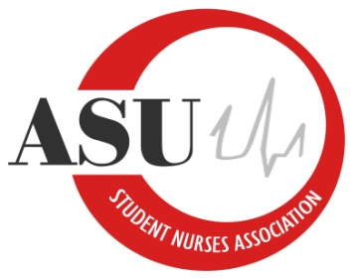
Arkansas State University Student Nurses’ Association
Board of Directors Regular Meeting
February 7, 2018
12:00 pm
St. Francis River Room
Meeting Minutes

- Call to Order:
- Roll Call:
President: Felicia Noel
Vice President: Karley Moore
Secretary: Lauren Gotte
Treasurer: Nick Kitchens
NEC Chair: Tiffany Woodsmall
BTN Chair: Ramon Garcia
Webmaster: Cebrina Swanson
Public Relations: Madison Dulin
Senior Class Representative: Mandi Finley
Junior Class Representative: Megan Belvedresi
Sophomore Class Representative: Alannah Davis
Accelerated BSN Representative: Ethan Lewis
Faculty Advisor: Lance Wilcox
Faculty Advisor: Dr. Bilinda Norman
Faculty Advisor: Addie Fleming
Visitors:

- Announcements
- Guest speaker for Up Till Dawn
- Steller Chapter submitted
- Dinner- Thank you
- Old Business
- Council of Student Leaders (COSL) March 17
- CPR classes for the Spring
- New Business
- Nationals- need information from Board for registration, SNA reimbursement for NCLEX review, Mr. Wilcox making Hotel reservations
- DKMS Bone Marrow Registry- Do we want to host one? It would be a great opportunity for community service.

- Discussion:

- The next meeting: March 7, 2018 St. Francis River Room

